**DCE Toolbox**

Designed for the analysis of DCE data, based on Tofts et al. (Tofts and Kermode, 1991).

The software package includes:

* DUSTER: DCE Up-Sampled Temporal Resolution Analysis Method - A proposed method for improving the extraction of AIF and PK parameters and estimates the BAT parameter (BAT ref).

Current Stable Version : DUSTER V2.6

* DCE Perfusion Analysis Method - For perfusion calculation from DCE data, incorporating the delay estimation allows to visualize another important parameter (Guys Ref).

**Installation**

**Requirements**

Operating system: Was tested on Microsoft Windows 7 and LINUX

System requirements: Matlab 8 + SPM8

**Software Installation**

Download the "Code" and "Tools" folders.

In Matlab, add the SPM8 and the code and the Tools path:

Matlab->File->Set Path...->Add with subdirectories->

**Data Import and Analysis Configuration**

Data Structure

DCE - All image files that form a data set for analysis should be located in a single directory.

The mandatory folders are: the dynamic data must be in a single series, and at least one series with different flip angels from the dynamic data.

DSC - The mandatory folders are: the dynamic data must be in a single series

**Team members:**

Head of the group: Dr. Dafna Ben Bashat: [dafnab@tlvmc.gov.il](mailto:dafnab@tlvmc.gov.il)

Main code written by: Dr. Gilad Liberman: [giladliberman@gmail.com](mailto:giladliberman@gmail.com)

Application and development: Moran Artzi: [artzimy@gmail.com](mailto:artzimy@gmail.com)

Development of the DCE Perfusion Analysis Tool: Guy Nadav: [guyov1@gmail.com](mailto:guyov1@gmail.com)

Development of the DSC Analysis Tool: Chen Harel: [chenharel1@yahoo.com](mailto:chenharel1@yahoo.com)

**Advanced DCE GUI Options**

\\fmri-guy2\Dropbox\University\Msc\Thesis\Git\dce_stable\Version_3.0

GUI Activation:

Activate Matlab and type:

cd \\fmri-guy2\Dropbox\University\Msc\Thesis\SourceForge\Stable_Versions\code\Version_2.6

%cd \\fmri-guy2\Dropbox\University\Msc\Thesis\SourceForge\Development

DCEInit

setComputerParamM('temppath','D:\Temp\'(

delete([fileparts(getComputerParams('infosfn')) filesep 'LastMainGUI.mat'])

%To forget stuff that auto-loads into MainGUI

dbstop if error

MainGUI

**DCE Maps**

**DCE maps created:**

**Ktrans** - map of the transfer coefficient of concentration between the bloood plasma and extravascular extracellular space (EES) given in 1/min.

**Ve** - map of total EES volume. Given in arbitrary units (0-1).

**Vp** - map of otal blood plasma volume. Given in arbitrary units (0-1).

**Kep** - map of the rate of consentaion ("Invers premability" - What returns blood vessels). given in 1/min.

**BAT** - map of bolus arrival time Ve. Given in secounds.

**RMS** - map of root mean squareerror map per voxel relative to the AIF

**rRMS3D and RMStoNoise** - normelized RMS maps

**>>Relaxometry folder:**

**T13DOFA** - T1 map

**PD3DOFA** - PD map

**RMS3DOFA** - RMS of relaxometry map

**Main GUI**

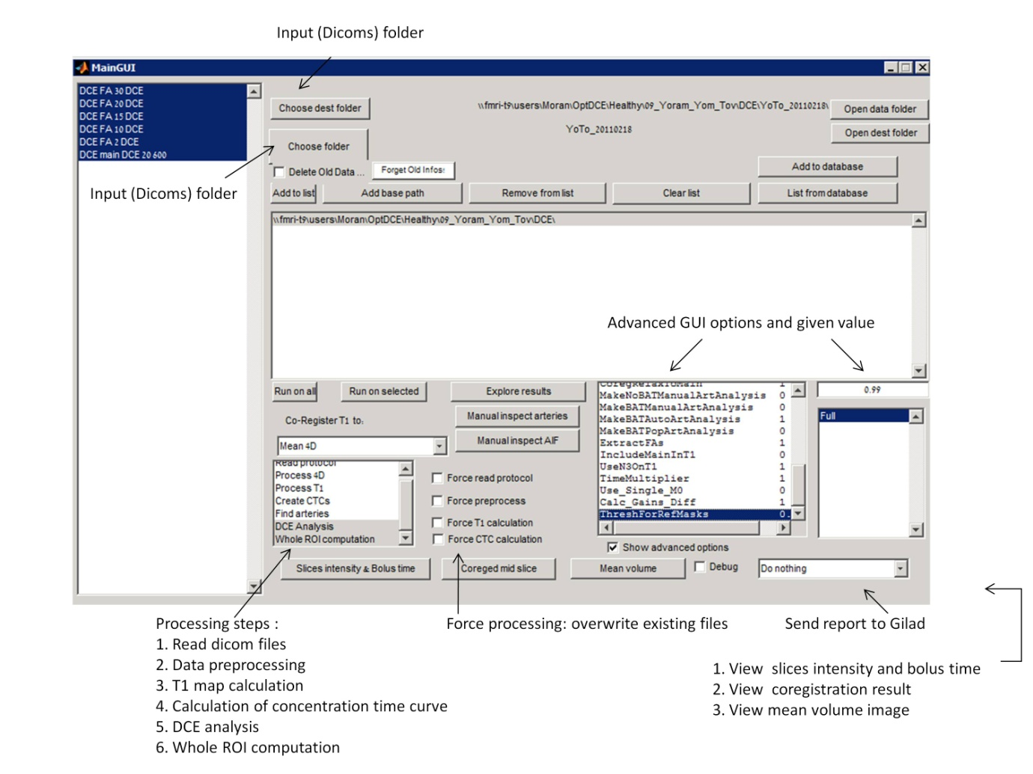

**Explore Results GUI**

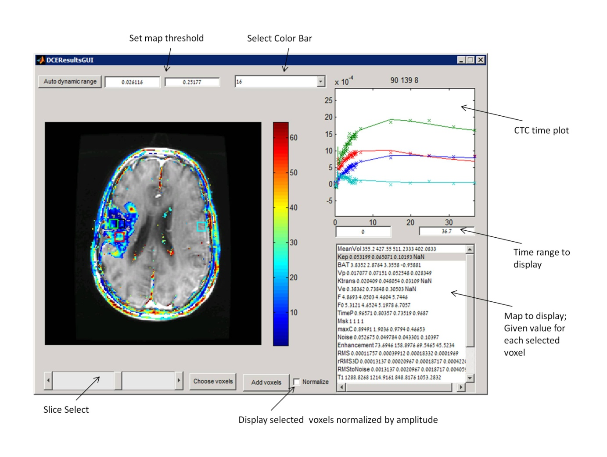

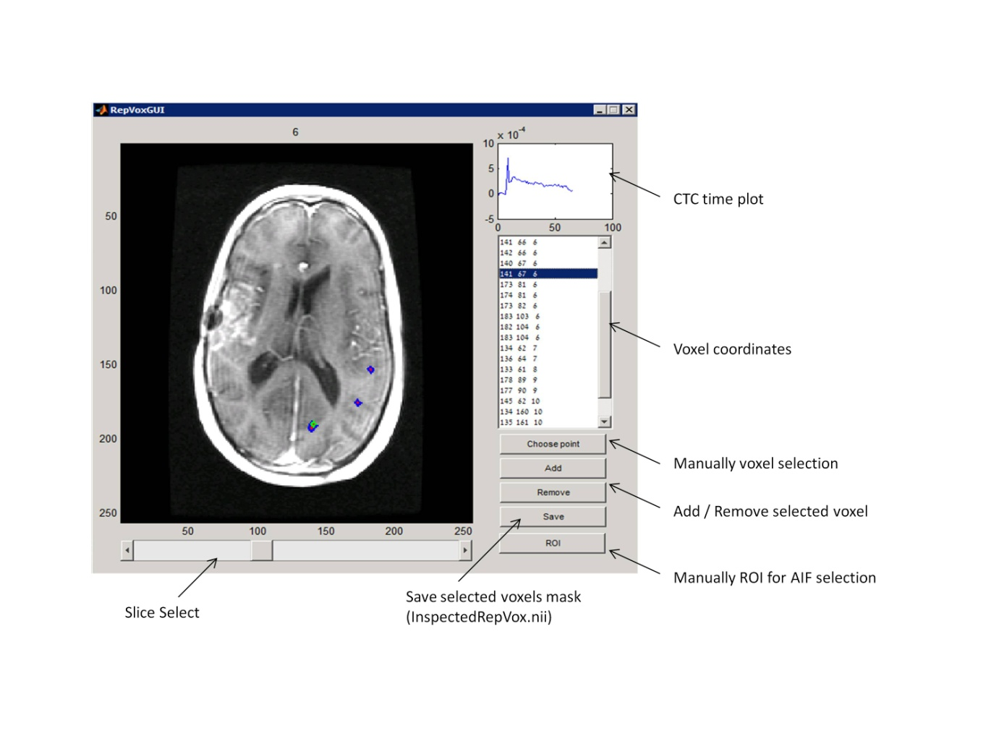**Manual Inspect Arteries GUI**

**Manual Inspect AIF GUI**

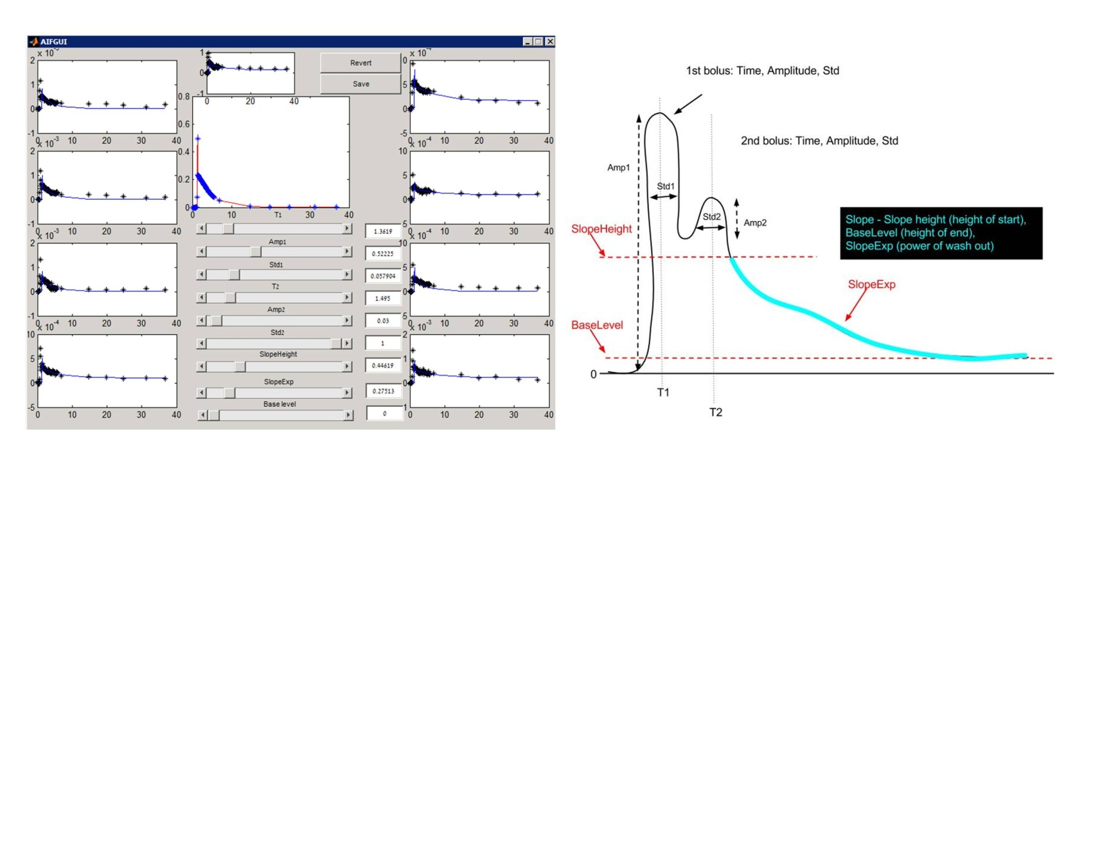

**Advanced DCE GUI options**

1. **SubSampling** – Allowing to sub-sample the original data (use lower temporal resolution)

Default: 1. DO NOT CHANGE (used for high resolution data). 3= for HTR change from 2sec to 6sec

1. **nVolsToRemoveFromStart** - Cut the first volumes of the test (for Siemens: the first volumes are distorted). Default: 0
2. **nVolsToRemoveFromEnd** - Cut the last volumes of the test (sometimes the last volumes are distorted). Default: 0
3. **SubSecondResolution** - Number of sub seconds parts for super resolution ("2" means 1/2 of a second). Default: 2
4. **MinFirstBolusStd** - The minimum width of the bolus (standard deviation of the Gaussian that represents the first bolus). Default: 2
5. **EM_Num_Of_Iterations** - Number of iterations for the Expected Minimization algorithm which finds the optimal AIF and parameters. ). Default: 5. (Currently not used).
6. **FMS_TolFun** - Function Minimum Search's (Matlab's) parameter. Tolerate Function – minimal improvement for continuing the search. Default: $e^{-11}$
7. **FMS_MaxFunEvals** – Number of possibilities for the F Mean Search at each step to change. Can think of it as in the case of 2-D vector f(**X**) ( How many 2-D points to move to from the current one). Default: 10000
8. **FMS_MaxIter** - Maximal Number of iterations for FMS algorithm. Default: 10000
9. **MaxTDif_ForAIFSearch** - The possible shift in time for the AIF of the representing voxels (in seconds). Default: 3
10. **MaxTDif_ForWholeVOI** - Same as MaxTDif_ForAIFSearch, just when allowing shifting in time for all voxels in VOI (and not just representing voxels). Default: 6
11. **Rep_MaxAroundBolus** - Number of clusters around the bolus (for finding representing voxels). Default: 10
12. **Rep_RatioToEnd** - Number of clusters around the end of the test (for finding representing voxels). Default: 10
13. **Rep_nPerSet** - Number of total clusters will be MaxAroundBolus *Rep_RatioToEnd. This option will determine how many representing voxels we will choose from each cluster. Default: 1
14. **Mask_Thresh** -Set threshold for masking (the general mask of where to work).

For positive values (0-1) uses SPM for masking.

For negative values (0 to -1) uses BET for masking.

The absolute value is passed to the SPM or BET.

Default: 0.5 (i.e., positive, uses SPM and the thresholds with 0.5).

1. **Run_On_All** - Run all processing steps. Default: 0(Currently not used).
2. **TimeDelayToMaskVeins** – Delay from Bolus peak. Default: -0.5
3. **WeightForAIFMeanVesses** –Similarity to the selected AIF Default: 0?
4. **MainCoregistration** - Choose between 1-realignment, 0-no motion correction and >=2 – coregister to that volume. Default: 1
5. **CoregRelaxToMain** - Do coregistration between Relaxometry and main. Default: 1
6. **MakeNoBATManualArtAnalysis** – If "1" and manualArt.nii exists, take the arteries from that file, take their average and make a regular calculation (we have AIF so we simply use Murase to get the PK parameters) without the possibility to shift BAT. Default: 0
7. **MakeBATManualArtAnalysis** - If "1" and manualArt.nii exists, take the arteries from that file, calculate the parameters using F Min Search on the picked arteries (instead of finding representative) and allow the possibility to shift BAT. Default: 0 (Currently not used).
8. **MakeBATAutoArtAnalysis** – The default mode of choosing the arteries automatically. Default: 1
9. **Extracted FAs** - Correct the flip angles of the scan (we assume there is an error).Default: 1 (Currently not used).
10. **IncludingMainInT1** - Default: 1. Include the DCE main (FA 20) in T1 calculation. (DO only if the DCE main acquired with the same calibration as the DESPOTs)
11. **UsingN3T1** -Do inhomogeneity correction. Default: 1
12. **TimeMultiplier** - Default: 1. can be used for time correction in Siemens data (insert the estimated TR: -6 for STR and -2 for HTR).
13. **Use_Single_M0** -Enable calculating T1 using a single angel.Default: 0
14. **Calc_Gains_Diff** -Enable/disable gains calculation made by Gilad. Default: 1
15. **ThreshForRefMask.** Default: 0.99 – threshold for the segmented WM mask (used as reference for T1 and Vp cakculation).

**Relaxometry coregistration - Use the list box:**

Can coregister to DCEMean ('Mean 4D'), use no coregistration (' No coreg’) or coregister to the median angle. Anyway will coregister the T1 map o DCE mean.

**To force AIF shape (parameters) calculated before:**

InspectedAIFParams.mat

**To add reference files insert NIFTI files named:**

RefVp_WM_830.nii

RefT1_WM_830.nii

Manual_BrainMask.nii

**For artery selection:**

InspectedRepVox.nii - Takes exactly what's there, or

ManualArtMask.nii- Looks for arteries only inside that mask.

**Supplementary scripts:**

**1**. **Fast Vp:**

Run FastVpMap.m script (after changing into the subject output folder )

Make maximum in the bolus area and extract FastVp.nii map into the subject AutoArtBAT folder

**2**. **Compare between Ewing and Sourbron's normalization:**

Run NormalizeByVeinsN.m script

Takes the Veins AUC and normalize to it

Gives figure with Jims normalization in blue and Sourbron normalization in Red and Magenta.

(The new normalization factor appears in the title)

>> Required input:

* Veins.nii binary mask with selected veins
* DCE output folder

>> Changing into the subject output folder

>> Set the Percent

**3. Change No of slices to remove:**

In DCET1_Prepare4Df.m script

Line 253:

BadSlices(~NaNSlices)=abs(MedSlice(~NaNSlices)-mean(MedSlice(MidSli-1:MidSli+1)))>50-Philips*30;

The number 50 == remove slice if the median of the slice signal is differ by more than 50% then the previous slice. Can be changed to 500 (less restricted thresholds).

**4. RUN ICA for AIF selection**

Run CTC_ica.m script

**Simulation of extended time points**

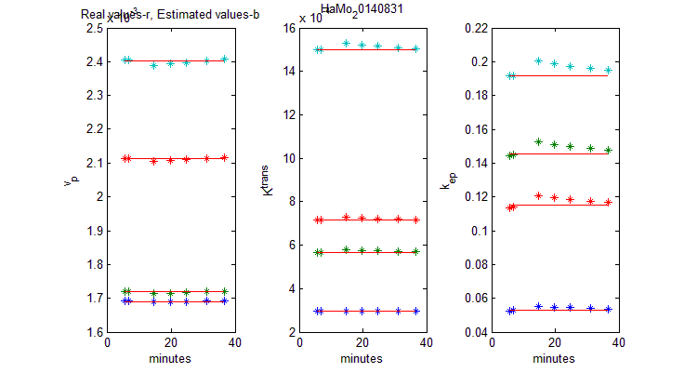Select Voxels of interest and 🡪 Export (Create Export.mat file in the current working directory)

Run SimLongTimeTest.m

Red line = "True" values [the simulated values = realistic values, driven from the selected voxels]

UseBAT=true / false = To run with or without BAT;

SSimsB=SSims.*(1+randn(size(SSims))*0.2); = Noise level (0.2=20%)

SKeps(:,k)=PKs_check(k,:,KepIdx); = Run with Model selection

SKeps(:,k)=PKs_check(k,:,**22**); = Run **without** Model selection

**csv file**:

#1= no of selected voxels

#2= "True" VP, KTRANS, KEP values, line with 3 cells for each vosel

#3= Scan time points [in min]

#4= Estimated **Vp** values for each time point (line for each voxel)

#5= Estimated **KTRANS** values for each time point (line for each voxel)

#6= Estimated **KEP** values for each time point (line for each voxel)

**Simulation of extended time points – Guy**

From

**\\fmri-guy2\SourceForge\Stable_Versions\code\Version_3.0\Code\DCE_Perfusion**

Run

**>>Simulation.m**

**>>** **Simulation_Set_Params.m**

* ***Free Parameters:***

Sim_Struct.ETM_Model - flag for using ETM model

* ***values for Simulation:***

Sim_Struct.Ktrans_ETM_low = 0.001;

Sim_Struct.Ktrans_ETM_max = 0.5;

Sim_Struct.Vp_ETM_low = 0.01;

Sim_Struct.Vp_ETM_max = 0.2;

Sim_Struct.Ve_ETM_low = 0.01;

Sim_Struct.Ve_ETM_max = 0.3;

* ***Simulation Time:***

Sim_Struct.total_sim_time_min

* *Time resolution:*

Sim_Struct.sec_interval

* ***Noise (higher=less noise):***

Sim_Struct.SNR_single

* ***No of iterations:***

Sim_Struct.num_iterations

* ***Use The same True values for different times***

Read the latest run parameters from the excel file

Sim_Struct.readLatestData = true [Use the same values]; false [DO NOT Use the same vales]

* ***Using constraints***

Sim_Struct.constraint = 'Rcheck = ( (Sim_Struct.Ve_ETM + Sim_Struct.Vp_ETM) > 1 ) | ( Sim_Struct.Ve_ETM > 1 ) | ( Sim_Struct.Vp_ETM > 1 );';

Sim_Struct.constraint = 'Rcheck = ( Sim_Struct.Vp_ETM > 1 );';

* ***Extended time to plot***

Sim_Struct.total_sim_time_min_to_plot = 20;

* ***Plot specific iterationt***

Sim_Struct.ETM_idx_to_plot

Output: exported_kep_simulation.xlsx

**DCE Perfusion GUI [Guy]**

Run [from Development]

Run following Gilad's DCE Tool and based in its results folder

Add Manual_BrainMask.nii map

Add Veins_Mask.nii mask

>> MainGUI_Perfusion

**Advanced DCE Perfusion GUI options**

**\*\*** **troubelshout – RUN DCEInit**

**Adjusted_Larsson_Model -** Default: 1 (troubelshout!)

**Use_Model_Selection-** Using model selection for the analysis. Default: 1

**Ignore_Delay_Model_Selection-** When using model selection, ignore models that include delay. Default: 0

**Correct_estimation_due_to_delay-** Correct and estimate BAT. Default: 1

**Min_Time_Delay-** Minimum time delay for BAT estimation. Default: 0

**Max_Time_Delay -** Maximum time delay for BAT estimation. Default: 10

**Force_RealData_Calc -** If we ran the analysis before, force it to run again and not skip it. Default: 1

**Parallel_Real_Data_Est-** Try to run the analysis on multi-core. Default: 1

**Correct_PVE-** Correct for partial volume effect. Default: 1

**AIC_Correction -** Correct Akaike model selection with the needed correction. Default: 1

**Data_Weight -** Weight of the RMS of data in Akaike. Default: 0.1

**poly_deg-** The polynom degree of the spline-basis. Default: 4

**knot_interval-** Number of knots in spline basis. Default: 5

**LQ_Model_AIF_Delay_Correct -** Use Linear-Quadratic model for BAT estimation. Default: 0

**Upsampling_resolution_Sec -** The up-sampling target of data. Controls the number of intervals in BAT

estimation. Default: 0.05

**Use_Cyclic_Conv_4_ht_est -** Use cyclic-deconvolution in BAT estimation. Default: 0

**Simple_AIF_Delay_Correct -** Use simple BAT estimation with taking the peak of the deconvolved AIF.

Default: 0

***use DCE_Perfusion without GUI ***

\\FMRI-GUY2\SourceForge\Stable_Versions\code\Version_2.7\Code\DCE_Perfusion

Run Test_On_Real_Data_Script.m

>> After editing the Red fields Run ReadRealData.m function

Subject_name  = 'ReYe';

Subject_Path  = '\\fmri-t9\users\Moran\DCE\HTR_STROKE\01_REMEZ_YECHEZKEL\Study20140615_114415';

WM_mask_absolute_path = [Subject_Path  '\RefAuto1_WM_830.nii'];

Art_Mask  = [Subject_Path  '\ManualArtMask.nii'];

After_CTC_mat   = [Subject_Path  '\AfterCTC.mat'];

%DCECoregP = [WorkingP 'DCEMainCoreged' filesep];

% \\fmri-t9\users\Moran\DCE\HTR_STROKE\01_REMEZ_YECHEZKEL

DCECoregP = [Subject_Path filesep 'DCE_out' filesep 'OrZe_20130811' filesep];

DCECoregP = '\\fmri-t9\users\Moran\DCE\HTR_STROKE\01_REMEZ_YECHEZKEL\';

**Include Bat Concoction**

In Simulation_Set_Params.m script, Set:

Sim_Struct.AIF_delay_low = 0;   -> -1

Sim_Struct.AIF_delay_max  = 3;   ->  20 (in stroke)

%Sim_Struct.Upsampling_resolution  = 0.1 / 60; % Set the upsampling target   -> 0.5/60

Sim_Struct.Upsampling_resolution_Sec = 0.1;

Sim_Struct.Correct_estimation_due_to_delay  = true;   % Try to correct for delay

**\*\*\*\*\*\*\*\*\*\*\*\*\*\***

**DSC - Perfusion [Chen]**

\\FMRI-GUY2\SourceForge\Stable_Versions\code\Version_2.6\Code\DSC

GUI Activation:

Activate Matlab and type:

DSCMainGUI

Click on **Init** button on the main Gui

**DSC GUI Manual**

**Stage #0 - initialization**

1. The MATLAB home directory should be set to "<something with development>\Code\DSC".
2. Run "DSCMainGUI.m" (from the directory mentioned above) 🡪 DSC GUI will be opened.
3. Click on "init" , in the upper-left part of the GUI.

**Stage #1 – Open the data**

1. Choose the file type you wish to open – (Dicoms or Nii) and click on "Choose data folder". A dialog box will be opened. Enter the directory containing the data files (and only them), mark the first file (either dcm or nii) and press "open". The selected path will be shown in the GUI.
2. Click "Choose output folder" to choose the folder that will contain coreged data files and the maps of the results.
3. Click "Get data". MATLAB will now open the data – can take some time. At the end of the process, "Read data successfully" message will be shown both in GUI and command Window.

**Stage #2 – Pre-processing**

At this stage we apply a few masks on the voxels, to get only the good ones for the next stages. A few options and parameters can be set:

1. You can choose to force Co-registration (even if your data is already coreged). In case the data is new and fresh, Co-registration will be done anyway.
2. Set the threshold for extracting the brain voxels ( a value between 0 and 1). The default should be 0.5.
3. Choose which filters to apply for masking the bad voxels:

* **Low average baseline** - Ignore voxels which are only noise - their average baseline intensity is below a certain threshold (default threshold – 500).
* **Wrong Bolus Peak** –
* **Bolus Saturation** - Check is a voxel's peak is divided to 2 adjacent peaks (so the bolus arrival signal is in saturation) – ignore these voxels.
* **Big Fluctuations** – Ignore voxels whose time-curve is fluctuating too much (the average abs value of the gradient is bigger than a certain value (default is 1.1 times the average abs gradient over the whole 4D data).
* **Low Steady State** - Ignore voxels whose steady-state value is too low to be physical (default is when steady-state mean is lower than baseline mean)
* **Low at Zero, Zero Values** – Currently should not be in use.

1. Click Pre-process to begin calculate the mask.

You can see the process in the command window:

After done pre-processing (can take some time), a figure will appear, showing the final mask (in red) for all the slices.

You can choose either to confirm and actually apply the filter (ignoring the non-red voxels in the next steps), or go back without applying the filter, choosing new filters to calculate.

Choosing the 2nd option (Back without applying filter) will bring you back to the main GUI, waiting for your new filter-choosing:

Now you can choose different filters and/or brain threshold, pre-process again, see the result mask, decide if it's good enough, and so on.

**Stage #3 – Specifying bolus properties**

After applying the mask (in the previous stage), two windows will be opened:

1. The first shows the time curves of about 20 randomly chosen voxels (the log of the intensity will be shown). The thick red vertical line indicates the bolus arrival time calculated automatically.
2. The 2nd window is the "bolus properties GUI", where you have to specify the time-curve parameters to be used (first and last baseline sample, and last sample of the whole curve). The intensity curves should help define these points.

After choosing the parameters, press OK.

You'll able to update the bolus properties from the DSC GUI itself, in the upper right side.

**Stage #4 – Choosing AIF**

After defining the bolus properties in the previous stage, the "Data Window" in the center-left of DSC GUI will be filled by the MRI image signal – You can choose the which time-point and slice to show, by using the sliding-bars in the right and the bottom of the image:

The AIF can be chosen by 3 methods: Manually by the user, automatically, or by loading an AIF text-file creating earlier by Pingwin or similar program.

**Manual AIF:**

* The user chooses voxels (by pressing on them with the mouse) to participate in building the AIF.
* A chosen voxel will be marked in yellow, and its coordinates will be written in the list in the right.
* Multiple voxels (in multiple slices) can be chosen.
* The final AIF will be the average of all chosen voxels.
* Deleting voxels from the list is possible.

**Auto AIF:**

Not available so far.

**AIF from file:**

Pressing that option will open a window to choose the AIF text file. The time-curve parameters chosen in stage 3 will now be updated according the data in that file. There is no need in pressing another key to produce the AIF. It is ready while choosing the voxels manually or after loading a file.

**Stage #5 – Producing the maps**

1. Choose which deconvolution methods to use (can mark more than one. each method will produce a map). Here is a list of the methods and parameters

|  |  |  |
| --- | --- | --- |
| Name | Description | Relevant parameters |
| sSVD | Standard SVD (Singular Value Decomposition) | Threshold |
| cSVD | Circular SVD, **without** minimization of oscillations. | Threshold |
| oSVD | Circular SVD, **with** minimization of oscillations. | OI (Oscillation Index) |
| Tikhonov | Tikhonov Regularization |  |

Note 1 : Maps calculation using cSVD and oSVD takes time, and using Tikhonov take a lot of time.

Note 2 : Changing a parameter becomes available only if the relevant method was chosen.

Note 3 : "P_reg" parameter is not used for now.

1. Mark the "permeability correction" if you want that the calculation of CBV will consider effects of permeability (The correction was proposed in the paper of Weisskoff 2006).
2. You can choose to calculate another parameter – TTP. (takes a lot of time).
3. Press "Produce Maps" button to start producing the maps. You can follow the process in the command window of MATLAB. A list of the methods will be shown, and also each slice being processed.
4. All maps will be saved to the output folder defined in stage #1, under the folder "results\maps_<date and time>".
5. You can open the results folder by pressing "Open Maps Folder":

**Summary of the maps created:**

* Mask.mat – the voxels mask that was used.
* CBV.mat – CBV with permeability correction.
* CBV_no_corr.mat – CBV without permeability correction.
* CBV_norm.mat –CBV nomarlized in the CBV of the AIF.
* CBF_sSVD.mat,CBF_cSVD.mat,CBF_oSVD.mat – CBF, depends on the method.
* MTT_sSVD.mat,MTT_cSVD.mat,MTT_oSVD.mat – MTT depends on the method.
* TTP.mat
* K1.mat , K2.mat – parameters of the permeability correction (refer to Weisskoff 2006).